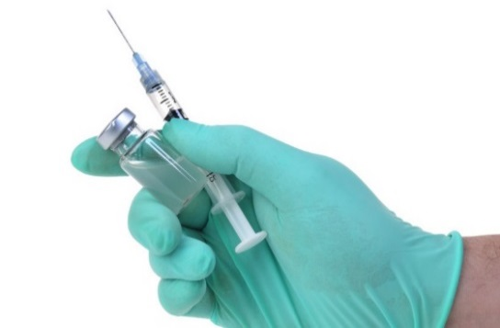  Highlights:  - A medication given by injection that prevents pregnancy  - Safe, effective, and convenient  - One shot lasts for 3 months  Remember:  - The Shot does not prevent HIV or other sexually transmitted infections (STIs). Protect yourself and others by also using condoms.  - If you are late getting the Shot and you have unprotected sex, you can take emergency contraception (EC) up to 5 days after sex to prevent pregnancy. | Fact Sheet:  Birth Control Shot  (Depo-Provera® or “The Shot”) | MRN:  Name:  D.O.B.:
 | What is the birth control shot (Depo-Provera®)?
The birth control shot (Depo-Provera®) is an injection that prevents pregnancy. The Shot contains a hormone that stops the ovaries from releasing an egg. You can't get pregnant if an egg is not released.
The Shot will keep you from getting pregnant for 3 months. Every 3 months, you will return to the clinic for another shot. If you wait longer than 3 months to get your next shot, you could get pregnant.
It’s possible you may not be able to get pregnant for up to 9-10 months after your last injection. But the Shot will not affect your ability to get pregnant in the future.
 | How do you use the Shot (Depo-Provera®)?
A medical provider will give you the Shot, usually in the arm or buttock.
If you get the Shot when you are not having your period, use condoms or do not have vaginal sex for the first 7 days. If you don’t use a condom or it breaks, seek emergency contraception (EC).
To continue to prevent pregnancy without interruption, you will need to come back to the clinic to get a shot every 13 weeks. Make sure to put the date of your next shot in your calendar.
 | What are the benefits of using the Shot (Depo-Provera®)?
It is effective. No method of birth control is 100% effective, but the Shot is 99% effective if you consistently get it on time (every 13 weeks). It is less effective if you are late getting the Shot.
It is convenient. There is no medicine to take every day or every week.
It is private. No one will be able to see it.
After one year of using the Shot, most women get fewer or lighter periods, or even no period at all.
 | What are the possible disadvantages of using the Shot (Depo-Provera®)?
Most women who use the Shot notice changes in their periods, especially in the first 6-12 months. Some women experience spotting (bleeding between periods) or longer, heavier periods. These changes in bleeding are not harmful.
Some women using the Shot experience side effects like change in appetite or weight gain, or changes in mood.
Women who use the Shot for many years may have decreased bone density. It will return to normal once you stop using the Shot.
 | Important! Learn these warning signs:
Although serious problems from using the Shot are very rare, there are warning signs of more serious problems that need to be checked right away. Call or come to the school clinic immediately if you experience any of these signs. If the school clinic is not open, go to the nearest emergency room.
- Severe headaches
- Very heavy vaginal bleeding (soaking 1 or more pads or tampons per hour)
- Depression
 | What if I am late getting my shot?
 | If you do not get the Shot on time, you will be at risk for pregnancy. If you are late for the Shot and have had unprotected sex, seek emergency contraception (EC) right away.
Patient Acknowledgment: I have read this fact sheet and understand the information given to me about the Shot (Depo-Provera®). I understand that I will need a pregnancy test today before receiving the Shot I understand it is my responsibility to follow the instructions on this fact sheet. No guarantee has been made to me as to the results of using the Shot. I understand that neither the provider nor the school clinic are in any way responsible should I become pregnant. If I do not get my period within 1 month of starting the shot, I will come back for a pregnancy test. I have been given the chance to ask questions about birth control and the shot in particular. My questions have been answered to my satisfaction.

Patient Signature: _____________________________________________________________ Date: _____/ _____/ _____ Updated 3/2017

