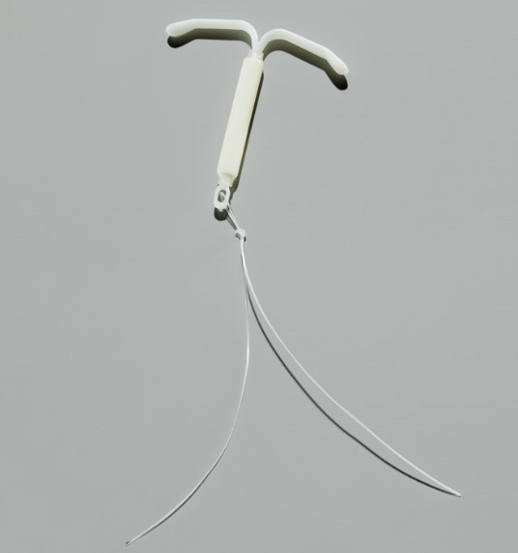  Highlights:  - A small “T”-shaped device inserted by a medical provider into the uterus to prevent pregnancy  - Safe, very effective, and convenient  - Lasts up to 5 years  - Must be inserted and removed by a medical provider  Remember:  - The IUD does not prevent HIV or other sexually transmitted infections (STIs). Protect yourself and others by also using condoms. | Fact Sheet:  Hormonal Intrauterine Device (IUD)  (Mirena®) | MRN:  Name:  D.O.B.:
 | What is the Hormonal IUD (Mirena®)?
The hormonal IUD (Mirena®) is a small “T”-shaped piece of plastic inserted by a medical provider into the uterus. It contains a hormone that is slowly released into the body. The IUD prevents pregnancy by stopping sperm from joining with the egg.
The IUD works for up to 5 years, but can be removed at any time by a medical provider. Once the IUD is removed, you may be able to become pregnant immediately. The IUD won’t affect your ability to get pregnant in the future.
 | How do you use the Hormonal IUD (Mirena®)?
A medical provider will insert the IUD into the uterus through the cervix. It is common for women to feel cramping or discomfort when and after the IUD is inserted. It will go away after a few days.
When the IUD is in place, strings attached to the IUD will stay in the vagina. These soften and become less noticeable over time. You can check for the strings if you want to, but don’t pull them and don’t let your partner pull them. Pulling could make it come out.
After the IUD is inserted, use condoms or do not have vaginal sex for at least the first 7 days. If you don’t use a condom or it breaks, seek emergency contraception (EC).
You can choose to have the IUD taken out at any time. If you would like it taken out, return to the clinic. Do not try to remove the IUD yourself.
 | What are the benefits of using the Hormonal IUD (Mirena®)?
The IUD is very effective. No method of birth control is 100% effective, but the IUD is more than 99% effective. It is one of the most effective birth control methods available.
It is convenient. There is no medicine to remember to take.
It is private. No one will be able to see it.
Your periods may be shorter and lighter. After several months, your period may go away. This change in bleeding is normal and is not harmful. Some women even like it. You may also have fewer cramps.
It works for up to 5 years, but you can have it removed at any time by a medical provider.
 | What are the possible disadvantages of using the Hormonal IUD (Mirena®)?
You may have cramps or pain while the IUD is inserted. After insertion, you may have cramps for a few days. Taking ibuprofen (Advil®) will help.
During the first 3-6 months, you may have spotting (bleeding between periods). After several months, you may have no period or bleeding at all. These changes in bleeding are not harmful.
 | Important! Learn these warning signs.
Although serious problems from using the IUD are very rare, there are warning signs of more serious problems that need to be checked right away. Call or come to the school clinic immediately if you experience any of these signs. If the school clinic is not open, go to the nearest emergency room.
- Any change in the length of the IUD strings or you can feel the hard plastic IUD. This means it could be coming out.
- Severe abdominal pain, fever (101.5°F or higher), or chills.
- Pain or bleeding during sex.
- Very heavy bleeding (like soaking 1 or more pads or tampons per hour) or many days of bleeding.
- You think you might have an infection (you have vaginal discharge, odor, or itching).
- You think you might be pregnant.
Patient Acknowledgment: I have read this fact sheet and understand the information given to me about the IUD (Mirena®). I understand that I will need a pregnancy test today before receiving the IUD. I understand it is my responsibility to follow the instructions on this fact sheet. No guarantee has been made to me as to the results of using the IUD. I understand that neither the provider nor the school clinic are in any way responsible should I become pregnant. If I do not get my period within 1 month of starting the IUD, I will come back for a pregnancy test. I have been given the chance to ask questions about birth control and the IUD in particular. My questions have been answered to my satisfaction.

Patient Signature: ______________________________________________________________ Date: _____/ _____/ _____ Updated 3/2017

