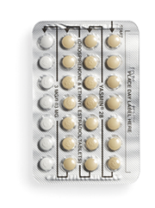  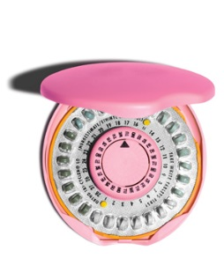  Highlights:  - A pill you take at the same time every day to prevent pregnancy  - Safe, effective, and convenient  Remember:  - The Mini-Pill does not prevent HIV or other sexually transmitted infections (STIs). Protect yourself and others by also using condoms.  - If you forget to take the Mini-Pill and you have unprotected sex, you can take emergency contraception (EC) up to 5 days after sex to prevent pregnancy. | Fact Sheet:  Progestin-Only Birth Control Pills  (“Mini-Pill” or “The Pill”) | MRN:  Name:  D.O.B.:
 | What are progestin-only birth control pills (the Mini-Pill)?
The progestin-only birth control pill (the Mini-Pill) is a pill you take every day. It contains a hormone that thickens the cervical mucus, which blocks sperm from getting to the egg. You can’t get pregnant if the sperm can’t get to the egg.
If you stop using the Mini-Pill, you may be able to become pregnant right away. The Mini-Pill won’t affect your ability to get pregnant in the future.
 | How do you use the Mini-Pill?
Take one Mini-Pill at the same time every day, whether or not you have sex that day. The Mini-Pill is not as effective if you don’t take it at the same time every day, so pick a time that is easy to remember. You can write down a good time to take the Mini-Pill here: _____________
When you start the Mini-Pill, use condoms or do not have vaginal sex for the first 7 days. If you don’t use a condom or it breaks, seek emergency contraception (EC).
After you finish the pill pack, start a new pack the next day, even if you still have your period.
 | What are the benefits of using the Mini-Pill?
It is effective. No method of birth control is 100% effective, but the Mini-Pill is 95% effective if you take it at the same time every day.
Your periods may be less painful or lighter.
 | What are the possible disadvantages of using the Mini-Pill?
Most women who use the Mini-Pill notice changes in their periods. Some women experience spotting (bleeding between periods) or longer, heavier periods. Some women stop getting a period. These changes in bleeding are not harmful.
You may have minor weight changes or changes in mood. These effects usually go away 2-3 months after starting the Mini-Pill.
 | What if I forget to take the Mini-Pill?
I forgot 1 pill Take it when you remember or take 2 pills together the next day. Use condoms or do not have vaginal sex for the next 7 days. If you don’t use a condom or it breaks, seek emergency contraception.

I forgot 2 or more pills Restart taking one pill a day and use condoms or do not have vaginal sex for at least the first 7 days after restarting. If you don’t use a condom or it breaks, seek emergency contraception (EC).
Patient Acknowledgment: I have read this fact sheet and understand the information given to me about the progestin-only birth control pill (Mini-Pill). I understand that I will need a pregnancy test today before receiving the Mini-Pill. I understand it is my responsibility to follow the instructions on this fact sheet. No guarantee has been made to me as to the results of using the Mini-Pill. I understand that neither the provider nor the school clinic are in any way responsible should I become pregnant. If I do not get my period within 1 month of starting the Mini-Pill, I will come back for a pregnancy test. I have been given the chance to ask questions about birth control and the Mini-Pill in particular. My questions have been answered to my satisfaction.

Patient Signature: ______________________________________________________________ Date: _____/ _____/ _____ Updated 3/2017

