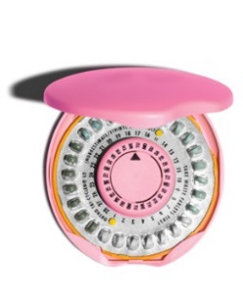  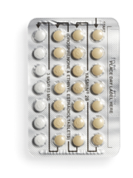  Highlights:  - A pill you take every day to prevent pregnancy  - Safe, effective, and convenient  Remember:  - The Pill does not prevent HIV or other sexually transmitted infections (STIs). Protect yourself and others by also using condoms.  - If you forget to take the Pill and have unprotected sex, you can take emergency contraception (EC) up to 5 days after sex to prevent pregnancy. | Fact Sheet:  Birth Control Pills (“The Pill”) | MRN:  Name:  D.O.B.:
 | What is the Pill?
The birth control pill (“the Pill”) is a pill you take every day. It contains hormones that prevent pregnancy in two ways. First, it may stop the ovaries from releasing an egg. You can't get pregnant if an egg is not released. Second, it thickens the cervical mucus, which blocks sperm from getting to the egg.
If you stop using the Pill, you may be able to become pregnant right away. It has no effect on your ability to become pregnant in the future.
 | How do you use the Pill?
Take one pill at the same time every day, whether or not you have sex that day. Pick a time that is easy to remember.
After you start the Pill, use condoms or do not have vaginal sex for at least the first 7 days. If you don’t use a condom or it breaks, seek emergency contraception (EC).
Most women who use the Pill get their period during the last week of the pill pack. If you don’t get your period during that week, it’s not harmful.
After you finish the pill pack, start a new pack the next day, even if you still have your period.
 | What are the benefits of using the Pill?
It is effective. No method of birth control is 100% effective, but the pill is 99% effective if you take it at the same time every day.
Your periods may be less painful, more regular, and lighter.
You may have clearer skin after a few months on the Pill.
The Pill may stop ovarian cysts from forming.
 | What are the possible disadvantages of using the Pill?
 | You may have nausea, spotting (bleeding between periods), minor weight changes, and/or breast pain or tenderness. These effects usually go away 2-3 months after starting the Pill.
 | Important! Learn these warning signs.
Although serious problems from using the Pill are very rare, there are warning signs of more serious problems that need to be checked right away. Call or come to the school clinic immediately if you experience any of these signs. If the school clinic is not open, go to the nearest emergency room.
• Abdominal Pain
• Chest Pain
• Headaches (severe)
• Eye Problems (such as loss of vision or blurry vision)
• Severe Leg Pain or Swelling
 | What if I forget to take the Pill?
I forgot 1 pill Take it when you remember that day, or take 2 pills together the next day.
I forgot 2 pills Take 2 pills as soon as you remember and take 2 pills together the next day. For example, if you forget on Thursday and Friday, take 2 pills on Saturday and 2 pills on Sunday. Use condoms or do not have vaginal sex for the next 7 days. If you don’t use a condom or it breaks, seek emergency contraception (EC).
I forgot 3 or more pills Start a new pack right away. Use condoms or do not have vaginal sex for the next 7 days. If you don’t use a condom or it breaks, seek emergency contraception (EC).
Patient Acknowledgment: I have read this fact sheet and understand the information given to me about the birth control pill (the Pill). I understand that I will need a pregnancy test today before receiving the Pill I understand it is my responsibility to follow the instructions on this fact sheet. No guarantee has been made to me as to the results of using the Pill. I understand that neither the provider nor the school clinic are in any way responsible should I become pregnant. If I do not get my period within 1 month of starting the Pill, I will come back for a pregnancy test. I have been given the chance to ask questions about birth control and the Pill in particular. My questions have been answered to my satisfaction.
Patient Signature: _______________________________________________________________ Date: _____/ _____/ _____ Updated 3/2017

